**Department of Electrical Engineering**

|  |  |
| --- | --- |
| **Faculty Member: Ma’am Qurat-ul-ain** | **Dated: December 27, 2020** |
|  |  |
| **Course/Section: BSCS-9B** | **Semester: 3rd** |
|  |  |

**Computer Organization and**

**Assembly Language (CS235)**

**Lab # 11 Reading Analogue Inputs and Outputs, and Analog to digital conversion (ADC) in Arduino using Tinkercad**

|  |  |  |  |  |  |  |  |
| --- | --- | --- | --- | --- | --- | --- | --- |
|  | | **PLO4** | | **PLO5** | **PLO8** | **PLO9** |  |
| **Name** | **Roll number** | **Viva /Quiz/ Lab performance**  **5 marks** | **Analysis of data in lab report**  **5 marks** | **Modern tool Usage**  **5 marks** | **Ethics and Safety**  **5 marks** | **Individual and team work**  **5 marks** | **Total**  **25 marks** |
| **Fatima Seemab** | **291310** |  |  |  |  |  |  |
| **Mahum Samar** | **290647** |  |  |  |  |  |  |
| **Maryam Fatima** | **290479** |  |  |  |  |  |  |

**Objective:** We will learn about analogue input and analogue output pins of arduino. We will also study Analog to digital conversion (ADC).



digitalWrite(pin ,value);//Value can be high or low;digital output

digitalRead(pin);// the Arduino pin number you want to read;digital input input block 



analogWrite(pin, value) //Analog output

in output block 



analogRead(pin)

 







**Example 1:**

Turn-on the led when we press the button and otherwise turn-off the led.

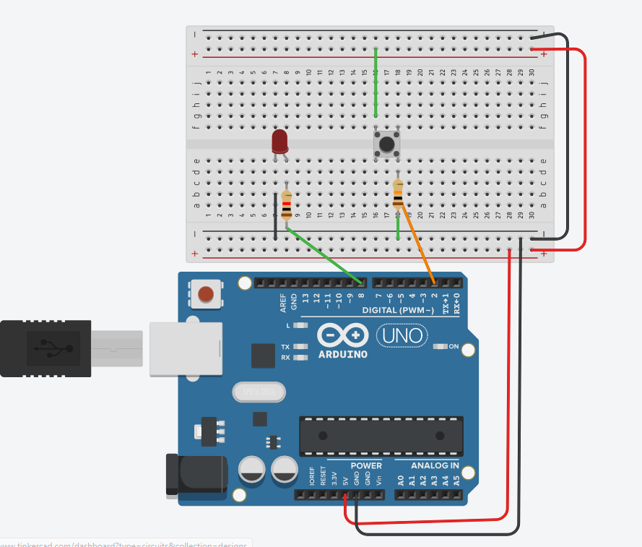



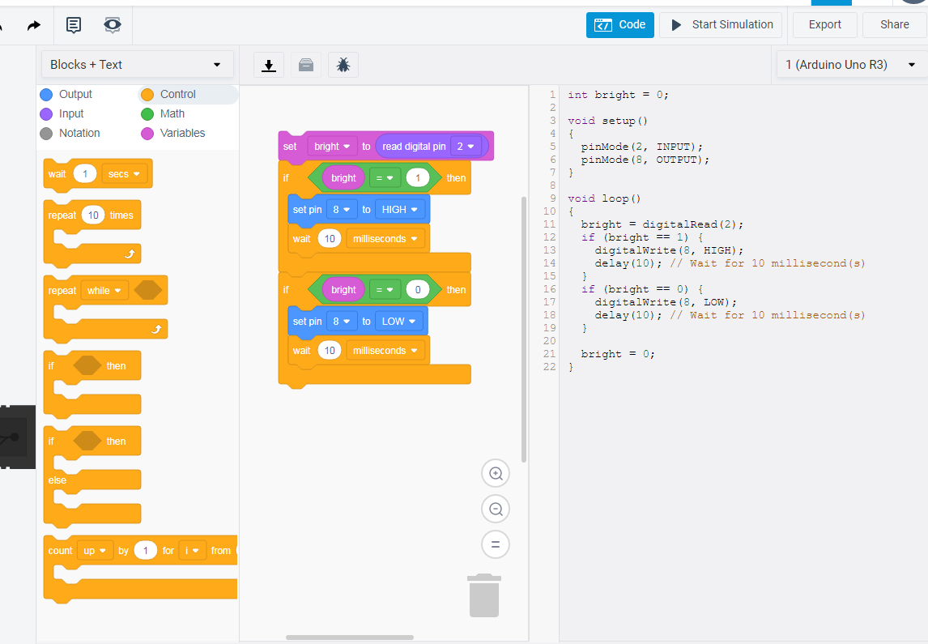



**Example 2:**

Control the brightness of the led using analogue output pin from minimum to maximum brightness

Circuit:

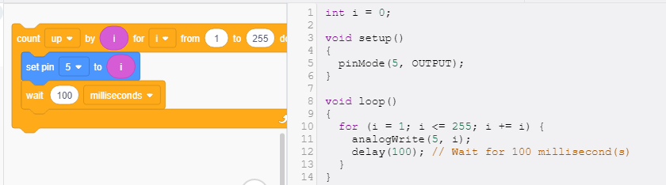



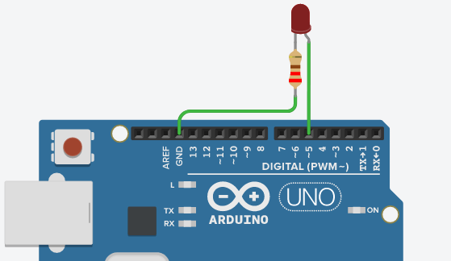

**Task 1:**

Turn-on the led from minimum brightness to maximum brightness when we press the button. Turn-off the led from maximum brightness to minimum brightness when we button is not pressed.

hint (Led will be analogue output pin. Button will be digital input). Provide link of your tinkercad task.

<https://www.tinkercad.com/things/7XEapKw8adV-coall11t1/editel?sharecode=uBg8tMs0KbluD_arsl9EmoHBhebon6J2osa9TTkqHUE>



**Task 2:** (Analogue input pin, values ranges from 0 to 1023)

Use the potentiometer instead of button. Connect it with analogue input pin of arduino. Code it in such a way that when potentiometer value is greater, led blink with larger delay. When potentiometer value is smaller, led blink with smaller delay.

Also at Minimum value of potentiometer is i.e., 0, led should fully ON.

At Maximum value of potentiometer i.e., 1023, led fully OFF. Provide link of your tinkercad task.

<https://www.tinkercad.com/things/jy9EIouI6Ti-coall11t2/editel?sharecode=0TiLAt_he6I7SgNzXKb8e690oto4xsXY4_h-cSvb1Yc>

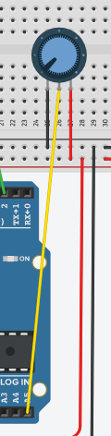

Connection with one of the analogue pin

**Task3:**

1. Design and code the circuit such that when photoresistor has minimum value, led show minimum brightness. As photoresistor value increases led brightness increases, and when photoresistor has max value, led show max brightness.

<https://www.tinkercad.com/things/4RzZbdPymBc-coall11t3a/editel?sharecode=A3HGilQT0tJDWckF4IDBQhR0pr1fv4EgSKA0gYpNTzQ>

1. Design and code the circuit such that when photoresistor has value <=500, led is off. When photoresistor has value >500, led On. Use serial monitor to print photoresistor value

<https://www.tinkercad.com/things/aM4IOsVF4QF-coall11t3b/editel?sharecode=7AOKKqPCzmrY5KnotKWXzI3CUVMphH3yG4r6loyQRs4>

